

February 8, 2018

**HUD Cut-blanks**

**Equipment**

Eastman HUD Cut-blanks

**Equipment List**

1. **Conveyor model 25-PVE24EZ.** Manufactured in 2013 by Hytrol.See photos and specification drawing.

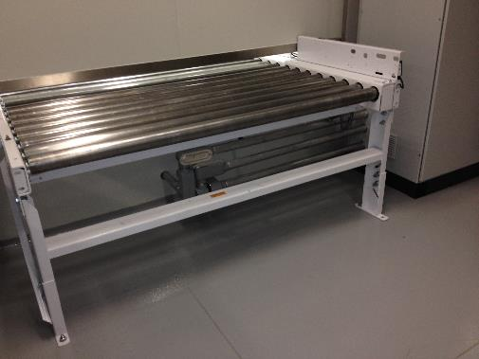

Picture 1a: Inlet conveyor

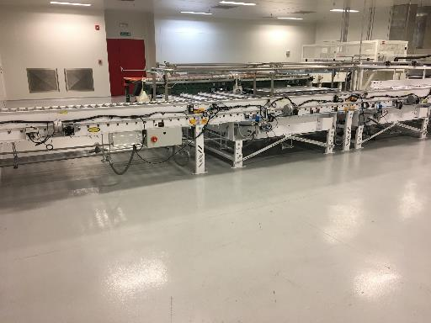

Picture 1b: Conveyor for plates



2

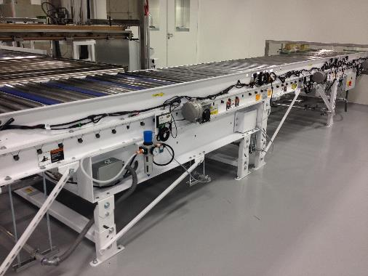

Picture 1c: Exit Conveyor

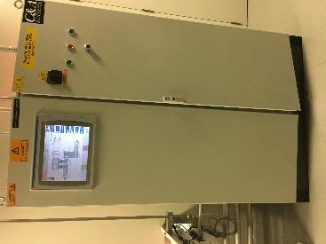

1d: Panel view Conveyor





1e: Machine manual available on purchase

3



1. **Unwinder and Cutting machine:** Manufactured in 2013 by Rosenthal Manufacturing Co. Inc.

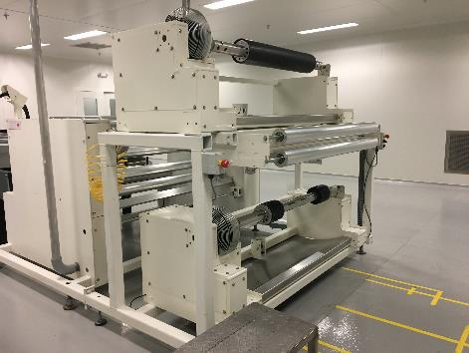

Picture 2a: Unwinder for 2 rolls, breakers, roll diameter measurement & accumulator for roll change

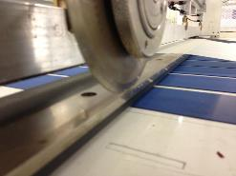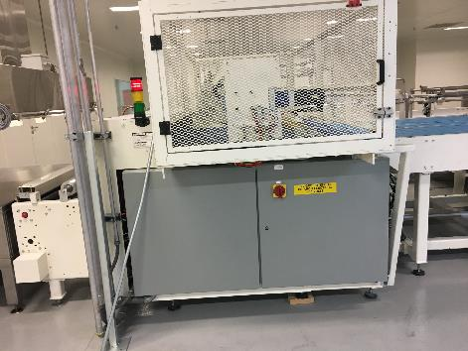

Picture 2b: Cutting machine with inlet accumulator.

Knife with movement for maximum +/- 10 degrees cut angle

4



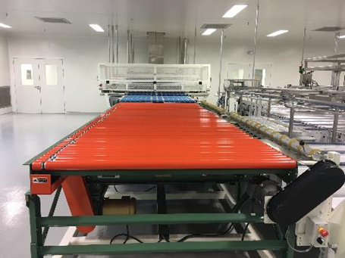

Picture 2c: Exit conveyors to send out blanks

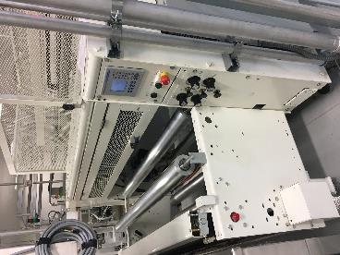



Picture 2d: Panel view for unwinder & cutting machine Picture 2e: Machine manual available on purchase



5

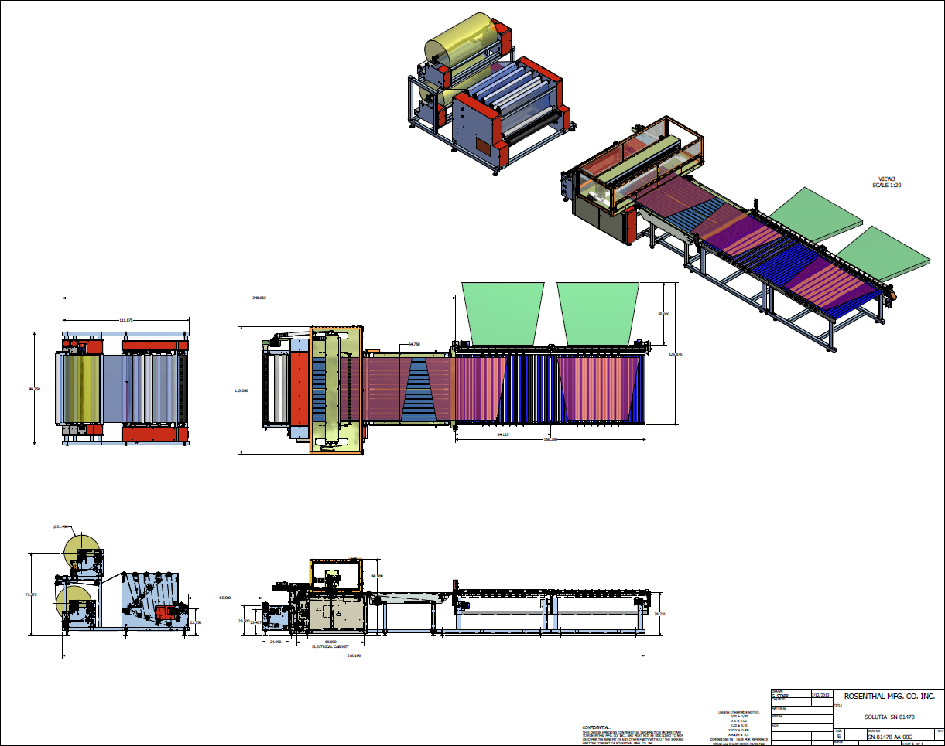

Picture 2f: Actual drawing will be provided in response to serious interest.

6

1. **Conveyor Oven (stainless steel construction):** Manufactured in 2013 by INTEK Corporation.

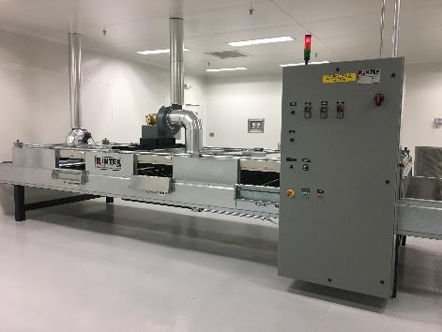

Picture 3a: Oven with safety doors, and temperature control panel.

Total Connected Load: 154 Kw, 480 V, 3 Ph, 60 Hz.

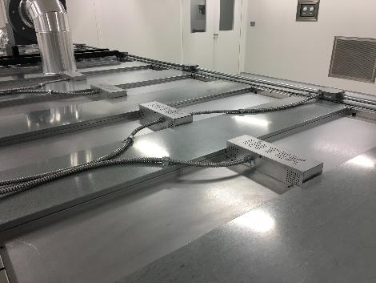

Picture 3b: Multizone heat control:

2 heat controls - 3 heat zones, wavelength 3.4 microns approximately 1,100°F (593°C).



7





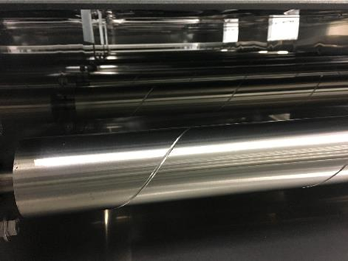

Picture 3c: Steel roller conveyor with VFD control,

adjustable from 16.25 fpm (5 m/min) to 65.6 fpm (20 m/min).



8

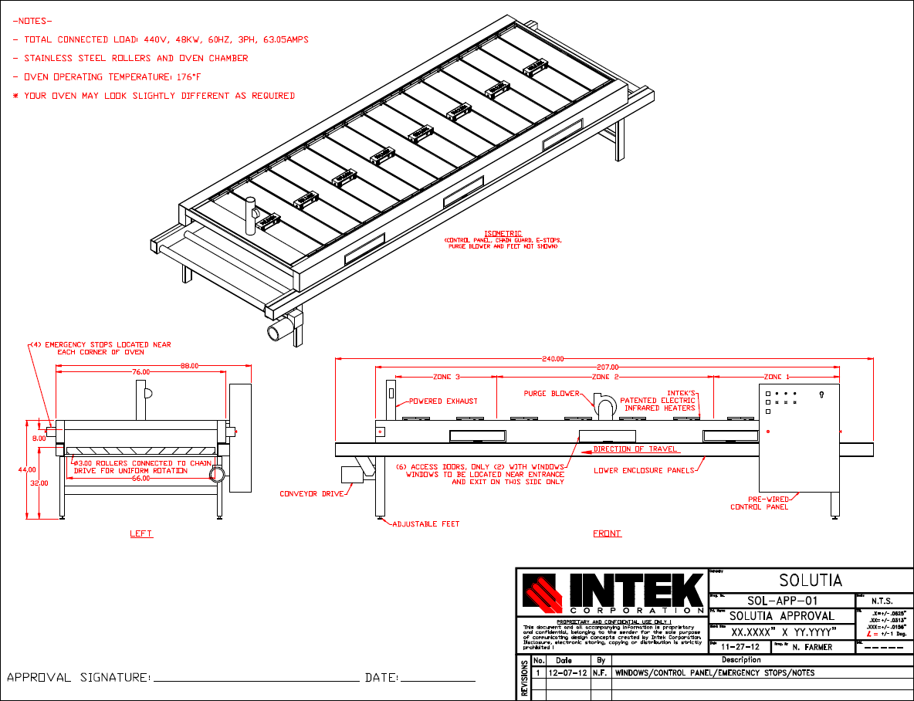

Picture 3d: Drawing for Windows/Control Panel/Emergency stops.



9

10

Picture 3e: Solutia Oven Control Address

**Approximate oven dimensions**

Internal oven chamber:

68” (1727mm) width

207” (5258mm) length

8” (203mm) height

**Overall external dimensions**

88” (2439mm) width (includes control panel)

240” (6096mm) length, including conveyor

72” (1525mm) height (includes purge and exhaust blowers)

1. **Cooling table and End conveyor**: Stainless steel cooling table. End conveyor is stainless steel and carbon steel construction. Manufactured in 2013 by EOLIS & Norte.

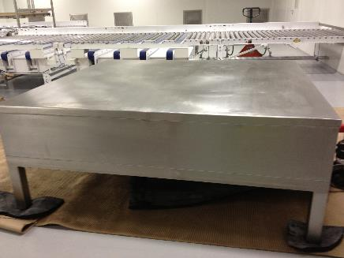

Picture 4a: Cooling table. Table is cooled with Chiller water.

Used for cooling down the PVB sheet after it’s gone through the oven.

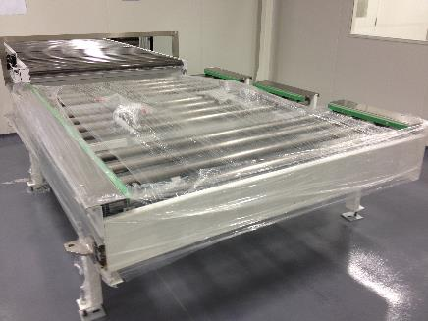

Picture 4b: End Conveyor with position detectors and VFD.

Equipment is used to enable transfer of HUD Cut-blanks to Pallet using a Lift Truck.

11

For more information, please contact your TS/AD Lead or Account Manager.

